Section I: Scenario Demographics

Scenario Title: | Pediatric Trauma in a Hemophiliac
Date of Development: | 25/04/2016 (DD/MM/YYYY)
Target Learning Group: | Juniors (PGY 1 – 2) Seniors (PGY ≥ 3) All Groups

Section II: Scenario Developers

Scenario Developer(s): | Donika Orlich
Affiliations/Institution(s): | McMaster University
Contact E-mail (optional): | orlichd@gmail.com

Section III: Curriculum Integration

Learning Goals & Objectives
Educational Goal: | To expose learners to a pediatric trauma in a patient with Hemophilia
CRM Objectives: | - Demonstrates leadership by maintaining control in a crisis and making prompt and firm decisions  - Demonstrates an organized and efficient problem-solving approach and collaborates with team while doing so
Medical Objectives: | - Initiates factor replacement for bleeding in the hemophiliac patient  - Performs a capacity assessment and outlines a plan of action for the incompetent patient

Case Summary: Brief Summary of Case Progression and Major Events
A 16-year-old female presents following an MVC. Past medical history is significant for hemophilia A. She has a laceration on her arm and a bruise on her forehead, but denies HA/N/V. The learner should recognize high potential for bleeding, and implement immediate treatment with rVIII replacement, along with pan-CT imaging. The CT head will show a small ICH. The patient wants to leave AMA following normal CT results, and the learner must preform a capacity assessment and outline a plan of action for the incompetent patient. The patient should be sedated and/or intubated anticipating decline using neuroprotective measures. Consults should be made to the ICU and hematology.

References
Marx, J. A., Hockberger, R. S., Walls, R. M., & Adams, J. (2013). Rosen's emergency medicine: Concepts and clinical practice. St. Louis: Mosby.
Website: E-medicine (accessed April 25, 2016) http://emedicine.medscape.com/article/779322-treatment#d9

Section IV: Scenario Script

A. Scenario Cast & Realism
Patient: | Computerized Mannequin |  |  |  |  | Realism:  Select most important dimension(s) |  |  | Conceptual
 | Mannequin |  |  |  |  |  |  |  | Physical
 | Standardized Patient |  |  |  |  |  |  |  | Emotional/Experiential
 | Hybrid |  |  |  |  |  |  |  | Other:
 | Task Trainer |  |  |  |  |  |  |  | N/A
Confederates | Brief Description of Role
Nurse | To assist with medication administration, clarify doses from learners, and prompt as to the status of the patient.
B. Required Monitors
EKG Leads/Wires |  |  | Temperature Probe |  |  |  | Central Venous Line
NIBP Cuff |  |  | Defibrillator Pads |  |  |  | Capnography
Pulse Oximeter |  |  | Arterial Line |  |  |  | Other:
C. Required Equipment
Gloves |  |  | Nasal Prongs |  |  |  | Scalpel
Stethoscope |  |  | Venturi Mask |  |  |  | Tube Thoracostomy Kit
Defibrillator |  |  | Non-Rebreather Mask |  |  |  | Cricothyroidotomy Kit
IV Bags/Lines |  |  | Bag Valve Mask |  |  |  | Thoracotomy Kit
IV Push Medications |  |  | Laryngoscope |  |  |  | Central Line Kit
PO Tabs |  |  | Video Assisted Laryngoscope |  |  |  | Arterial Line Kit
Blood Products |  |  | ET Tubes |  |  |  | Other: rVIII replacement
Intraosseous Set-up |  |  | LMA |  |  |  | Other:
D. Moulage
Laceration to right arm (5cm), bleeding actively.
Bruise over R temporal area
E. Approximate Timing
Set-Up: |  | 5 min |  | Scenario: | 20 min |  |  | Debriefing: |  | 40 min

Section V: Patient Data and Baseline State

A. Clinical Vignette: To Read Aloud at Beginning of Case
You are working in a level three trauma center and are told that EMS just arrived from an MVC involving a 16-year-old female passenger who has known hemophilia. Vitals are stable. She has a laceration to her arm, and a bruise on her head, but has GCS 15 and only complains of arm pain.
B. Patient Profile and History
Patient Name: Cintia Puzenski |  |  |  |  |  | Age: 16 |  |  |  |  |  |  |  | Weight: 50kg
Gender: M F |  |  |  |  |  | Code Status: Full
Chief Complaint: Right arm pain.
History of Presenting Illness: MVC about 50km/hr. She was belted passenger in front seat. No injuries to driver (mother). No airbags deployed.
Past Medical History: |  | Hemophilia A |  |  |  |  | Medications: |  |  |  |  | No prior humate P or DDAVP
 |  | Previous admissions for spontaneous joint bleeds x3 and spontaneous epistasis x1, all requiring transfusion |  |  |  |  |  |  |  |  |  | rVIII prophylaxis 30IU/kg IM M/W/F
Allergies: None
Social History: Attends high school. Lives with parents. No EtOH, drugs, smoking
Family History: No family history of hemophilia, other bleeding disorders
Review of Systems: |  | CNS: |  |  | Denies HA, N/V. No vision changes. No paresthesias.
 |  | HEENT: |  |  | Denies neck pain.
 |  | CVS: |  |  | No CP, no presyncope
 |  | RESP: |  |  | No SOB. No hemoptysis
 |  | GI: |  |  | No abdominal pain.
 |  | GU: |  |  | Hasn’t voided since accident.
 |  | MSK: |  |  | Pain R arm (still bleeding) |  |  |  |  |  |  |  | INT: |  | Nil
C. Baseline Simulator State and Physical Exam
No Monitor Display |  |  |  | Monitor On, no data displayed |  |  |  |  |  |  | Monitor on Standard Display
HR: 110/min |  |  | BP: 120/80 |  |  |  |  | RR: 14/min |  |  |  |  |  |  | O₂SAT: 100% RA
Rhythm: sinus |  |  | T: 36ºC |  |  |  |  | Glucose: 5 mmol/L |  |  |  |  |  |  | GCS: 15 (E4 V5 M6)
General Status: Alert & Oriented. Complaining of R arm pain/bleeding.
CNS: | Alert and oriented with GCS 15. No focal neuro deficits. C-collar in situ.
HEENT: | PERRL 4mm. No signs basilar skull #. Bruise R temporal area (non-boggy). Airway clear.
CVS: | Normal S1, S2. No murmurs.
RESP: | GAEB. No crackles. No crepitus.
ABDO: | Soft. No bruising. Non-tender.
GU: | No hematuria with foley.
MSK: | 5cm superficial lac R forearm with active bleeding |  |  |  |  |  |  |  | SKIN: | Normal colour

Section VI: Scenario Progression

Scenario States, Modifiers and Triggers
Patient State | Patient Status | Learner Actions, Modifiers & Triggers to Move to Next State
1. Baseline State  Rhythm: sinus  HR: 110/min  BP: 120/80  RR: 14/min  O₂SAT: 100%  T: 36ºC | Comfortable but complaining of R arm pain.  ++ bleeding from arm laceration | Learner Actions  - IV, monitors  - Labs (CBC, INR, G&S, factor VIII level, BhCG, basic labs)  - 1L IV NS bolus  - ABCDE primary survey  - Control local bleeding  - Analgesia  - rVIII 50U/kg  - TxA 1g IV over 10min  - FAST US exam  - Portable CXR, PXR  - CT Head, C-spine, Chest, Abdo, Pelvis  - Arm x-ray  - Hematology consult | Modifiers  Changes to patient condition based on learner action  - Analgesia given HR 90  - Laceration sutured/pressure dressing applied bleeding slows  - Laceration not addressed by 3 minutes nurse to cue “she’s bleeding a lot from that arm”  Triggers  For progression to next state  - 8 minutes or all learner actions complete 2. Back from CT (assume 20 minutes passed)
2. Back from CT  Rhythm: sinus  HR: 95/min  BP: 125/80  RR: 12/min  O₂SAT: 100% | **At state onset, verbal report from radiology “small ICH, no shift”  Patient initially complains of mild HA. Vomit x1 in scanner. Two minutes into state, patient wants to leave AMA | Learner Actions  - Re-assess patient  - rVIII & TxA if not already given  - Check cap sugar  - IV/IM sedation for agitation  - ± Plan for intubation  - Neurosurgery consult  - Hematology consult (if not yet done) | Modifiers  - No sedation by 12 mins patient pulls out IV & becomes verbally aggressive  Triggers  - Verbalize plan for intubation 3. Intubation  - No plan for intubation but patient sedated and actions complete 4. Labs Back
3. Intubation  Rhythm: sinus  HR: 100/min  BP: 120/80  RR: 15/min  O₂SAT: 100 % | Patient calm after sedation given | Learner Actions  - RA Pupils/neuro exam prior to paralysis  - Pre-oxygenate with 100%  - Neuro-protective measures  - Elevate head of bed  - Post-intubation CXR & sedation | Modifiers  - Propofol given BP 95/70, HR 105  Triggers  - Intubation complete 4. Labs Back
4. Labs Back  Rhythm: sinus  HR: 85/min  BP: 115/75  RR: 12/min  O₂SAT: 100% | * start state by giving labs to team | Learner Actions  - ICU consult  - Discuss with Heme if any further management required | END CASE PRN

Section VII: Supporting Documents, Laboratory Results, & Multimedia

Laboratory Results
Na: 140 | K: 4 |  |  | Cl: 105 |  | HCO₃: 25 |  | BUN: 5 |  | Cr: 80 |  |  | Glu: 5.5
VBG |  | pH: 7.38 |  |  | PCO₂: 40 |  | PO₂: 95 |  | HCO₃: 25 |  |  | Lactate: 2.2
WBC: 5 |  |  | Hg: 110 |  |  |  | Hct: 0.4 |  |  |  | Plt: 250
INR: 1.0 |  |  |  |  | PTT: 45 (increased)

Images (ECGs, CXRs, etc.)
Normal CXR  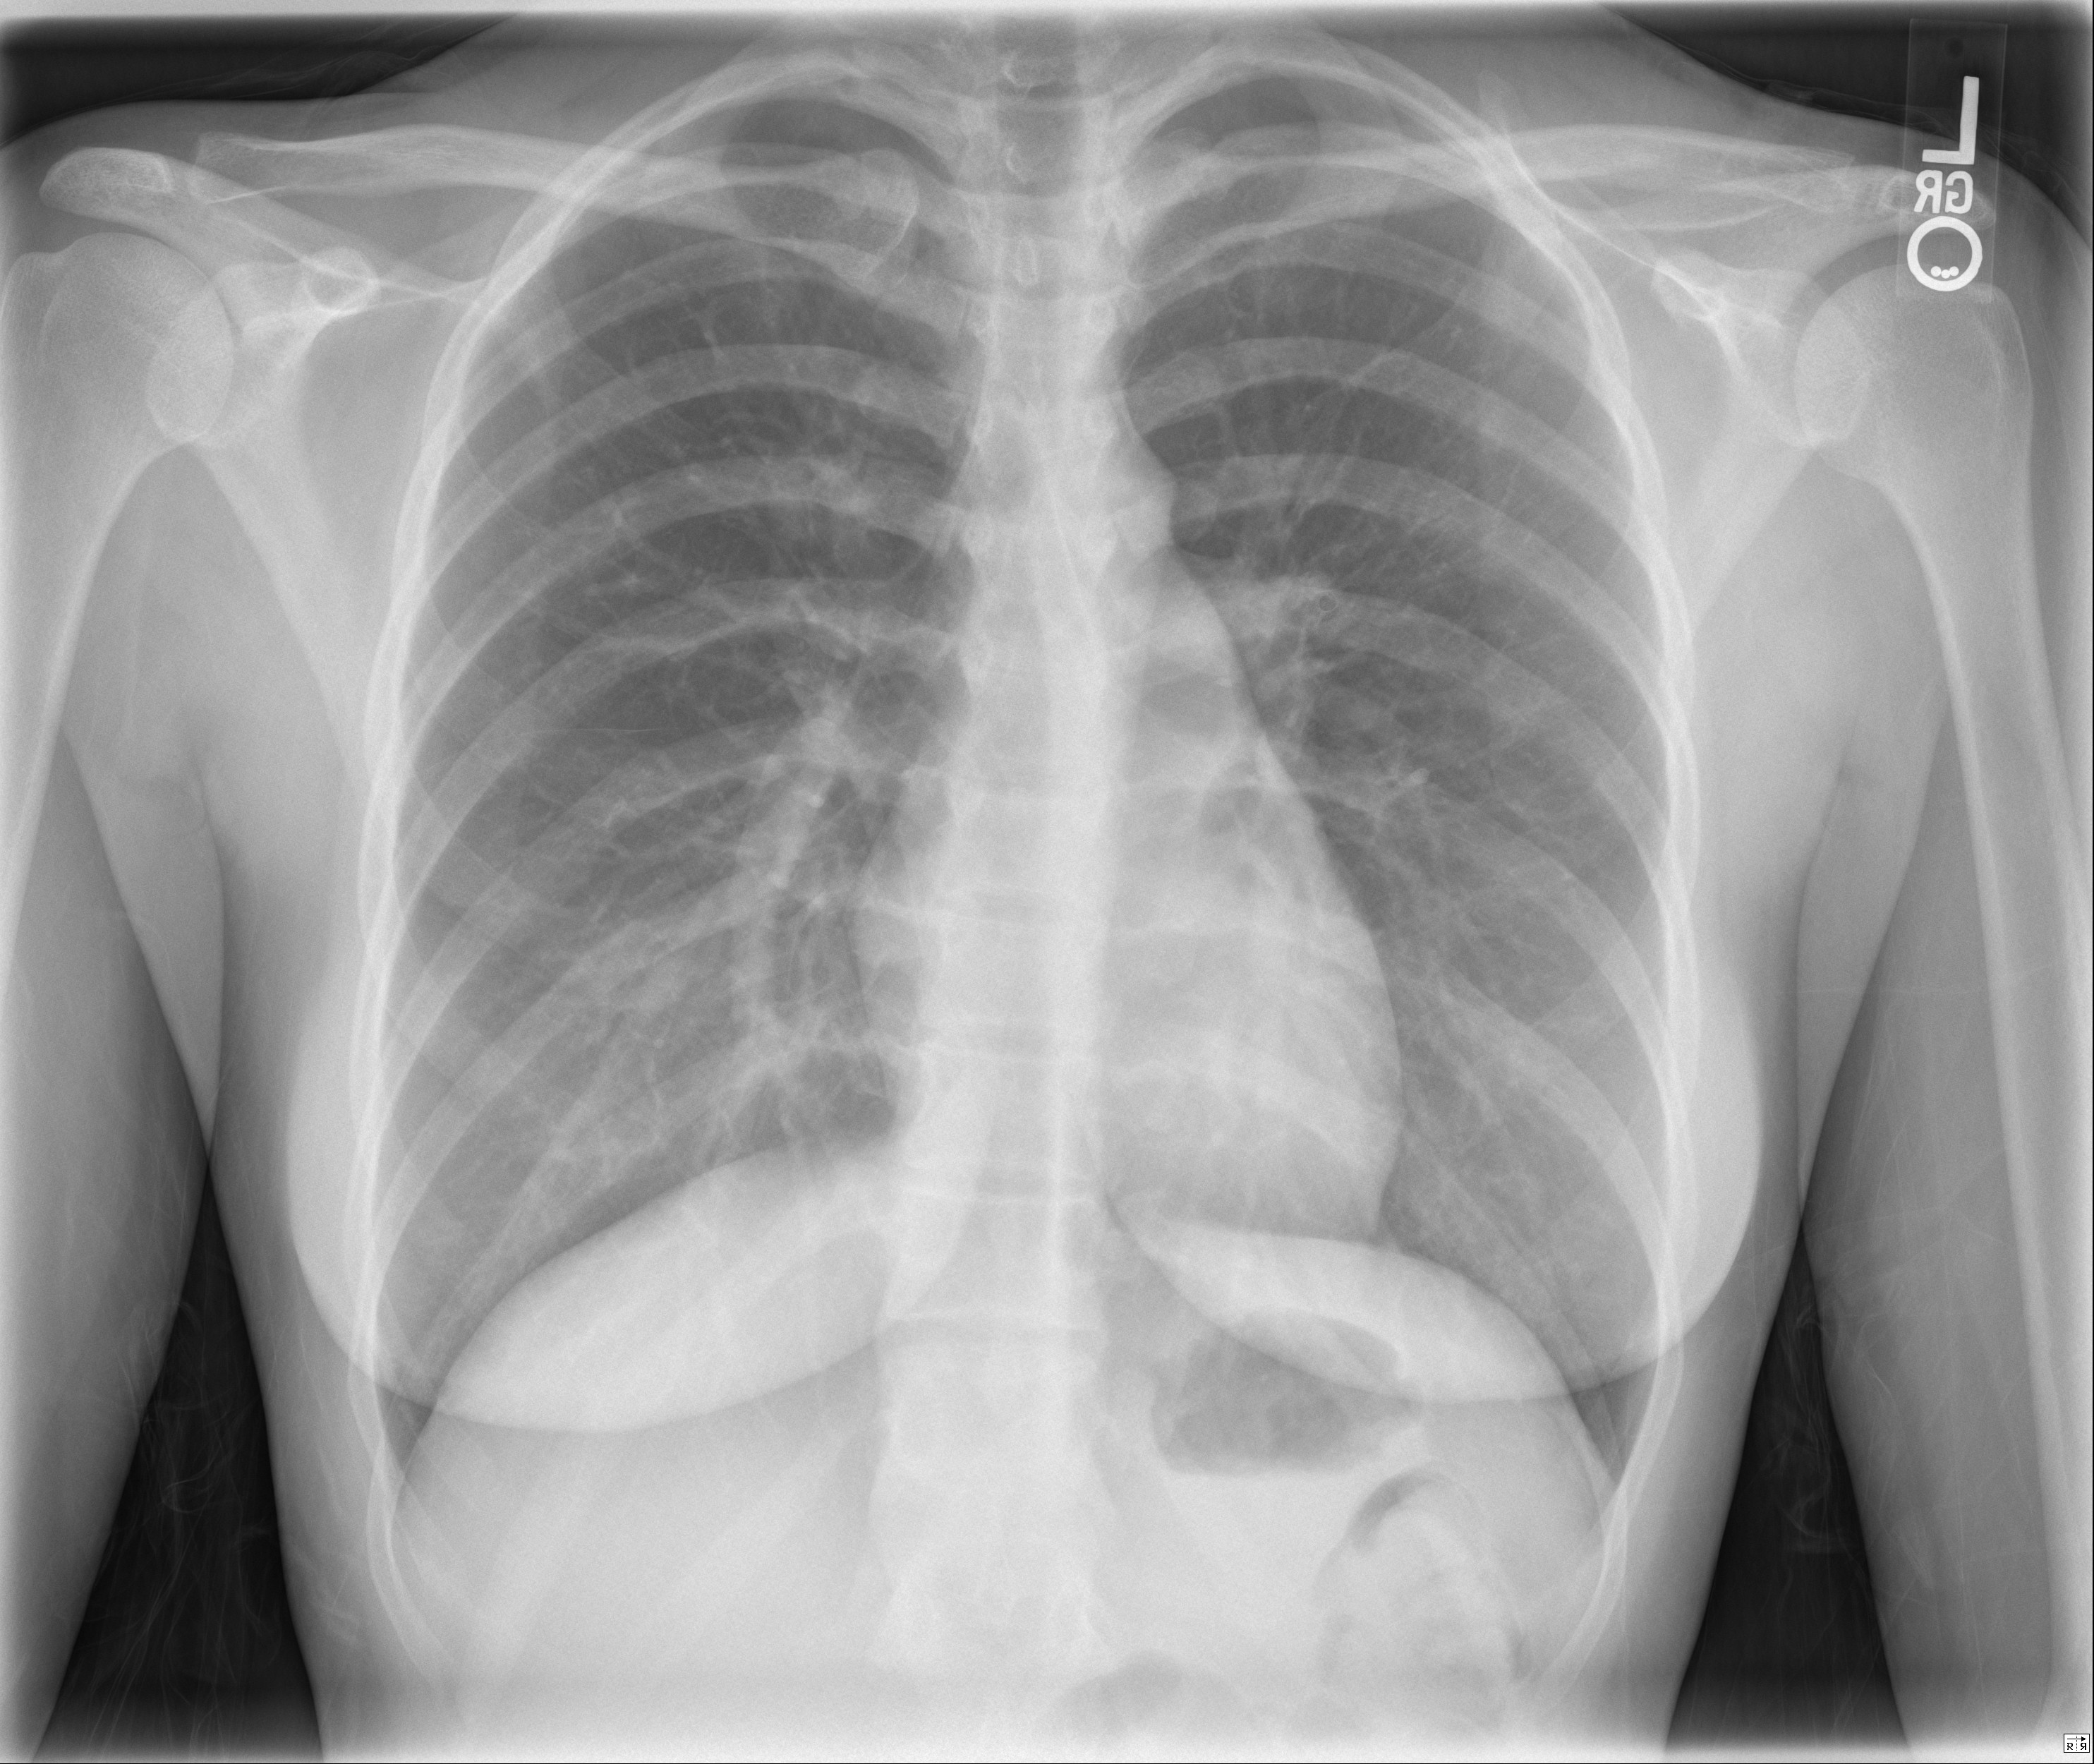  CXR source: https://radiopaedia.org/cases/normal-chest-radiograph-female-1 | Normal Pelvis X-ray  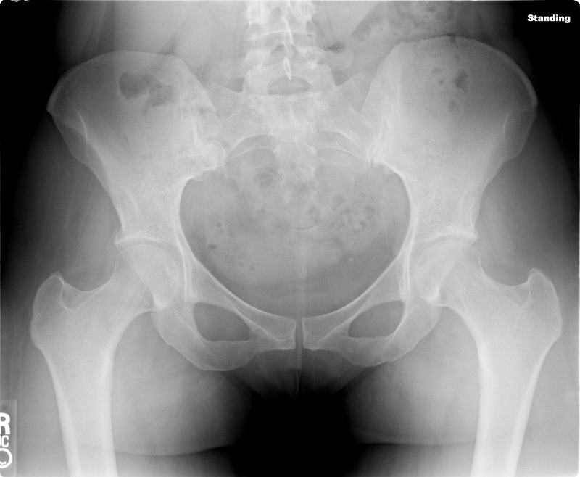  PXR source:  http://radiopaedia.org/articles/pelvis-1
Normal R Forearm  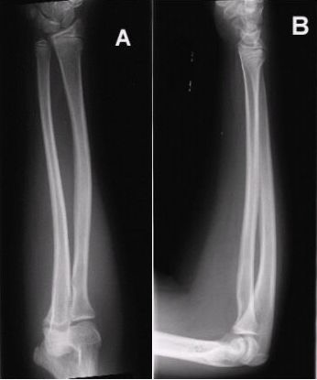  Xray source: http://www.auntminnie.com/  index.aspx?sec=ser&sub=def&pag=dis&ItemID=56736 | ECG: sinus tachycardia  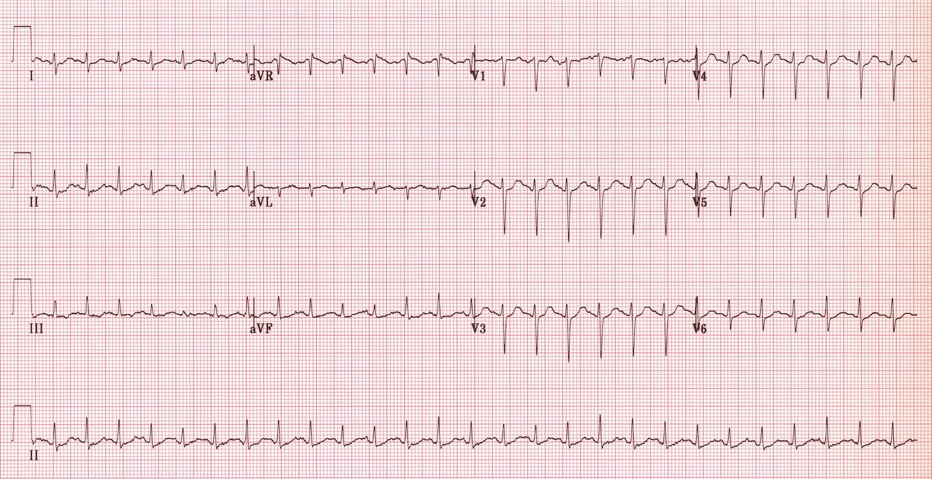  ECG source: https://lifeinthefastlane.com/ecg-library/sinus-tachycardia/
Ultrasound Video Files (if applicable)
No FF on FAST | No pericardial fluid
Section VIII: Debriefing Guide

General Debriefing Plan
Individual | Group |  | With Video | Without Video
Objectives
Educational Goal: |  | To expose learners to a pediatric trauma in a patient with Hemophilia
CRM Objectives: |  | - Demonstrates leadership by maintaining control in a crisis and making prompt and firm decisions  - Demonstrates an organized and efficient problem-solving approach and collaborates with team while doing so
Medical Objectives: |  | - Initiates factor replacement for bleeding in the hemophiliac patient  - Performs a capacity assessment and outlines a plan of action for the incompetent patient
Sample Questions for Debriefing
- How did you tailor your approach to trauma in this hemophiliac patient?
- What was your approach to managing this patient wanting to leave AMA?
- What would have been your ultimate disposition for this patient had the CT head been normal?
- Did you feel comfortable with the management of this patient? What are the key elements to take away from a patient like this to increase comfort in the future? How else would you access this information?
Key Moments
- Recognize head injury as a carrying severe bleeding risk and initiating prompt rVIII replacement immediately (even in the absence of symptoms)
- Makes early consultation with hematology
- Capacity assessment

